**PROJECT 2 - REMOTE CONTROL OF THE RPI**

**1. Screenshot of your remote computer connected to your RPi using SSH.**

**Sol:** Successfully access the raspberry pi remotely to remote computer with ‘PUTTY’ and ‘VNC viewer’ by using SSH.

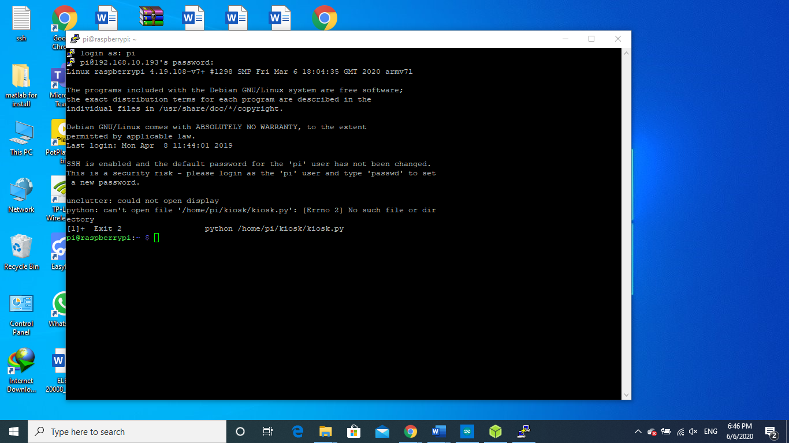



**2. Source code for your blinkers.sh script.**

**Ans:**

echo 0 | sudo tee /sys/class/leds/led0/brightness

echo 0 | sudo tee /sys/class/leds/led1/brightness

while :

do

echo 0 | sudo tee /sys/class/leds/led0/brightness

echo 1 | sudo tee /sys/class/leds/led1/brightness

sleep 1

echo 0 | sudo tee /sys/class/leds/led1/brightness

echo 1 | sudo tee /sys/class/leds/led0/brightness

sleep 1

done

**3. Short video of your RPi blinking the LEDs based on your blinkers.sh script.**

The video of the output of the ‘blinker.sh’ is given below. Open this video by double clicking on the package.



**4. Describe your approach to this project. List any problems that you’ve encountered and how you overcame these issues.**

**Ans:**

As the project name shows that in this project, we remotely control the raspberry pi from another computer. As we already discuss, we have two ways to connect our raspberry pi with remote computer. So first of all Add ‘SSH’ file in the raspberry pi OS image card. For this remove the SD card from the raspberry pi and insert into the card reader of the laptop. Once the raspberry pi image OS drive is shown in your laptop then by right clicking and navigate to the ‘New’ menu select on the text file. Now you can rename the file and remove its extension. We have to made SSH file having no extension. Also, we add ‘wpa-configuration’ file which contain the wireless network credentials which helps the raspberry pi to wirelessly connect the wi-fi network.

When you again place the SD card in the raspberry pi and boot up the pi. The system starts. Once the pi boots up it will automatically connect with the wireless network. Now hold the remote computer and open ‘PUTTY’. Make connection type ‘SSH’ in putty. You have to enter the IP address of the raspberry pi in the putty in order to connect your raspberry pi on remote computer.so for this you must know the IPv4 range of the network. Use ‘IP scanner’ software to find the IP address of the raspberry pi.

Once you get the pi IP address. Enter this in ‘PUTTY’. The PUTTY make connection between two computer and you will see terminal on screen. Now terminal ask for username and password of the raspberry pi. Enter these PI credentials complete the connection and now you can use command line interface or terminal of the raspberry pi with the help of PUTTY. While if you want to get full functions with raspberry pi screen on your remote computer you can use ‘VNC Viewer’ for this purpose. By using VNC viewer you can use the raspberry pi on your laptop.

When you have PI screen on your laptop then open terminal. Make nano text file and save this file as shell script with name ‘blinkers.sh’. In this file type your bash code for blinking the power led and activity led alternatively. after this save the file and exit. The files we created in the raspberry pi have only permission to read to rad these files from the root. But we have to make this file executeable.so for this we have to change the permission of the file .for this we use ‘chmod command’ with file bit either 5 0r 7.when you change the file permission to execteable , run the file and see that the leds are blinking alternatively.

There are few problems I encountered while making this project. I face problem in making file executable because before making this file permission must be changed. So, this problem can be overcome by changing the file permission and file become easily executables. Also, I face problem in connecting the raspberry pi with the computer. Because in start I don’t know the raspberry pi IP address even. This problem is overcome by using the ‘IP Scanner’ software.